**Ryan Long**

**DSC640**

**1.2 Exercises: Charts**

**Datasets used:**

hotdog-contest-winners.xlsm

obama-approval-ratings.xls

**Summary**

I hadn’t used Power BI extensively prior to this exercise. I found it to be intuitive and required little effort to create the graphs as it felt familiar to creating graphs in Excel and Word. Creating the graphs in Python was similarly easy as I have been using it primarily throughout this course work. I found R to be the most challenging as I have not used it much beyond the initial classes of this program which included a temporary hiatus of my course work.

As someone who will most likely use these tools in a casual or supplementary sense in the workplace, I gravitate towards Power BI and Python as future solutions. I believe those entrenched in data science daily either in a professional setting or academics would lean more towards R. Both Python and R offer near unlimited flexibility as compared to the out of the box nature of Power BI.

**The following pages contain:**

Power BI – Bar chart

Power BI – Stacked Bar chart

Power BI – Pie chart

Power BI – Donut chart

Python – Bar chart

Python – Stacked Bar chart

Python – Pie chart

Python – Donut chart

R – Bar chart

R – Stacked Bar chart

R – Pie chart

R – Donut chart

**Appendix**

Code support for both Python and R notebooks

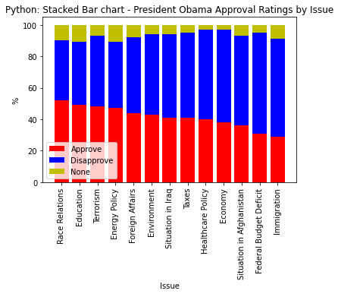

APPENDIX